This code is not synthesizable because n is used as a variable loop limit. In FPGA hardware, all loop limits must be fixed at compile time so the synthesis tool knows exactly how many adders to create in the circuit. Since n could change during operation, the hardware would need to reconfigure itself to add more or fewer numbers, but FPGAs are static after programming and cannot change their structure at runtime.
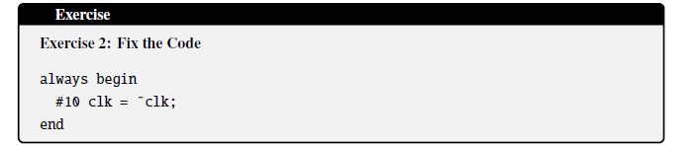
- Always block needs to know when to execute, it should be always @(posedge clk) or always @(*). Without this, the simulator does not know when to trigger.
- FPGAs cannot wait 10 nanoseconds in code. Clock signal needs to be provided externally.
- We cannot create a clock using regular logic gates
- No reset is written. Without a reset, clk will start at 0 or 1 randomly.
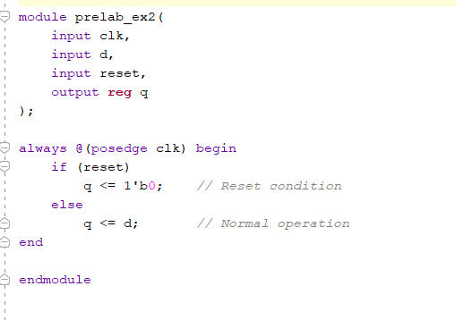
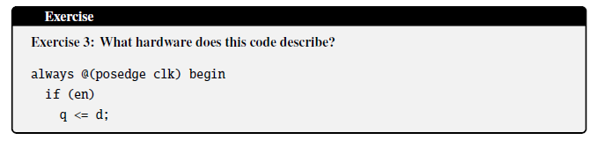
This code describes a D Flip-Flop with Clock Enable.
When en is 1: the clk has a rising edge, and q is updated (gets d).
When en is 0, there will be no change, and q retains its previous value.
Since the output depends on the current state as well as the previous input, this is a sequential circuit.

